CREATE A DATABASE IN CLOUDANT DB

|  |  |
| --- | --- |
| Date | 29 october 2022 |
| Team ID | PNT2022TMID32971 |
| Project Name | IoT Based Safety Gadget for Child Safety  Monitoring & Notification |

* To create a database in Cloudant DB to store location dataSteps:

1. Log in to IBM Cloud account
2. Click “Create Resource +” button

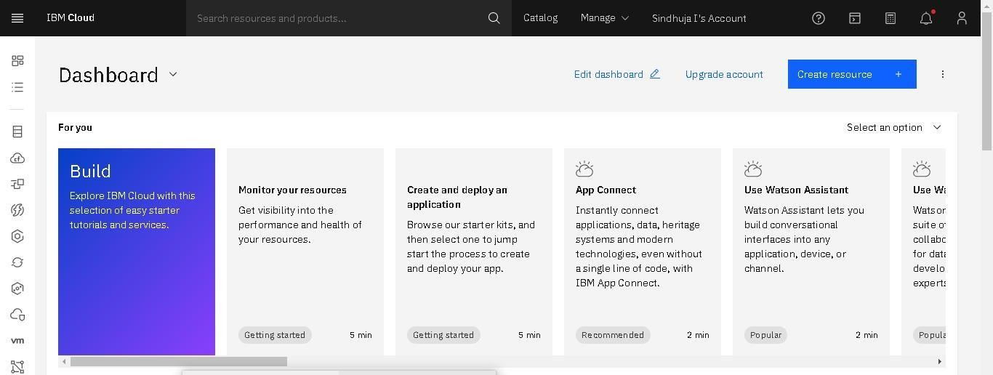

1. Search for “Cloudant”
2. Choose the “Lite Version”
3. Click on “Create”

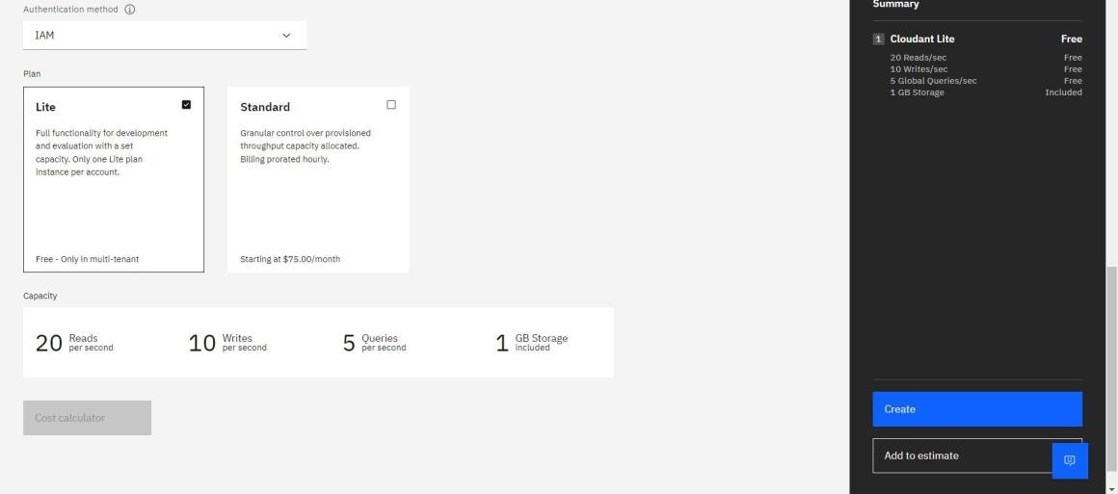

1. The Cloudant database resource created

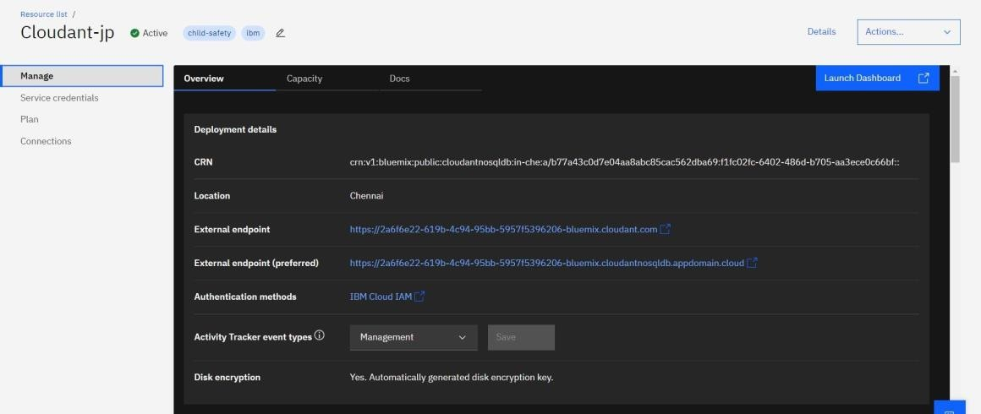

1. click on launch dashboard

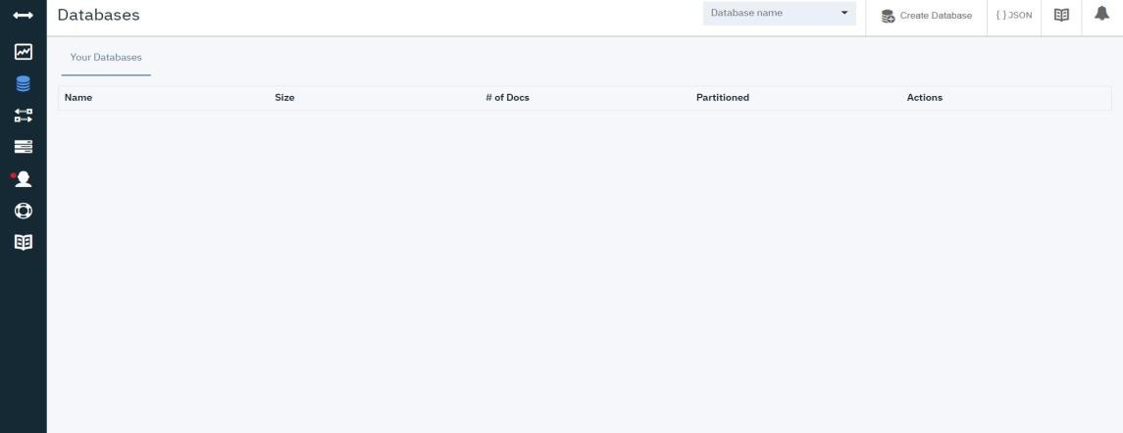

1. Click “Create Database”. Entered “Nivetha” as the database name and the “Non-partitioned” option
2. The database “Nivetha” has been created.

Conclusion:

A database to store the location data on Cloudant Database has been created successfully.